DLD Lab mid

Mohammad Yehya Hayati, 21K-3309, BCS-2G

Table of Contents

**Question #1:** 2

**Question #2:** 3

**Part #1:** 3

**Part #2:** 4

**Question #3:** 5

**Question #4:** 6

# **Question #1:**

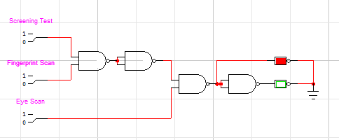

|  |  |  |  |
| --- | --- | --- | --- |
| **Screening Test** | **Fingerprint Scan** | **Eye Scan** | **LED(OPEN)** |
| 0 | 0 | 0 | Red |
| 0 | 0 | 1 | Red |
| 0 | 1 | 0 | Red |
| 0 | 1 | 1 | Red |
| 1 | 0 | 0 | Red |
| 1 | 0 | 1 | Red |
| 1 | 1 | 0 | Red |
| 1 | 1 | 1 | Green |

# **Question #2:**

## **Part #1:**

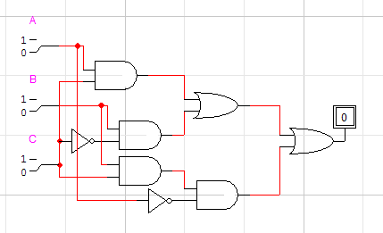

|  |  |  |  |
| --- | --- | --- | --- |
| **A** | **B** | **C** | **Output** |
| 0 | 0 | 0 | 0 |
| 0 | 0 | 1 | 0 |
| 0 | 1 | 0 | 1 |
| 0 | 1 | 1 | 1 |
| 1 | 0 | 0 | 0 |
| 1 | 0 | 1 | 1 |
| 1 | 1 | 0 | 1 |
| 1 | 1 | 1 | 1 |

## **Part #2:**

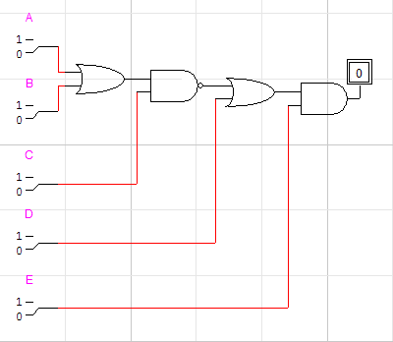

|  |  |  |  |  |  |
| --- | --- | --- | --- | --- | --- |
| **A** | **B** | **C** | **D** | **E** | **Output** |
| 0 | 0 | 0 | 0 | 0 | 0 |
| 0 | 0 | 0 | 0 | 1 | 1 |
| 0 | 0 | 0 | 1 | 0 | 0 |
| 0 | 0 | 0 | 1 | 1 | 1 |
| 0 | 0 | 1 | 0 | 0 | 0 |
| 0 | 0 | 1 | 0 | 1 | 1 |
| 0 | 0 | 1 | 1 | 0 | 0 |
| 0 | 0 | 1 | 1 | 1 | 1 |
| 0 | 1 | 0 | 0 | 0 | 0 |
| 0 | 1 | 0 | 0 | 1 | 1 |
| 0 | 1 | 0 | 1 | 0 | 0 |
| 0 | 1 | 0 | 1 | 1 | 1 |
| 0 | 1 | 1 | 0 | 0 | 0 |
| 0 | 1 | 1 | 0 | 1 | 0 |
| 0 | 1 | 1 | 1 | 0 | 0 |
| 0 | 1 | 1 | 1 | 1 | 1 |
| 1 | 0 | 0 | 0 | 0 | 0 |
| 1 | 0 | 0 | 0 | 1 | 1 |
| 1 | 0 | 0 | 1 | 0 | 0 |
| 1 | 0 | 0 | 1 | 1 | 1 |
| 1 | 0 | 1 | 0 | 0 | 0 |
| 1 | 0 | 1 | 0 | 1 | 0 |
| 1 | 0 | 1 | 1 | 0 | 0 |
| 1 | 0 | 1 | 1 | 1 | 1 |
| 1 | 1 | 0 | 0 | 0 | 0 |
| 1 | 1 | 0 | 0 | 1 | 1 |
| 1 | 1 | 0 | 1 | 0 | 0 |
| 1 | 1 | 0 | 1 | 1 | 1 |
| 1 | 1 | 1 | 0 | 0 | 0 |
| 1 | 1 | 1 | 0 | 1 | 0 |
| 1 | 1 | 1 | 1 | 0 | 0 |
| 1 | 1 | 1 | 1 | 1 | 1 |

# **Question #3:**

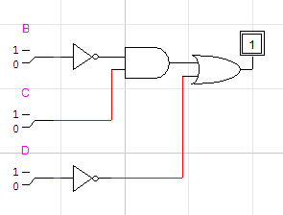

|  |  |  |  |  |
| --- | --- | --- | --- | --- |
| **A** | **B** | **C** | **D** | **Output** |
| 0 | 0 | 0 | 0 | 1 |
| 0 | 0 | 0 | 1 | 0 |
| 0 | 0 | 1 | 0 | 1 |
| 0 | 0 | 1 | 1 | 1 |
| 0 | 1 | 0 | 0 | 1 |
| 0 | 1 | 0 | 1 | 0 |
| 0 | 1 | 1 | 0 | 1 |
| 0 | 1 | 1 | 1 | 0 |
| 1 | 0 | 0 | 0 | 1 |
| 1 | 0 | 0 | 1 | 0 |
| 1 | 0 | 1 | 0 | 1 |
| 1 | 0 | 1 | 1 | 1 |
| 1 | 1 | 0 | 0 | 1 |
| 1 | 1 | 0 | 1 | 0 |
| 1 | 1 | 1 | 0 | 1 |
| 1 | 1 | 1 | 1 | 0 |

# **Question #4:**

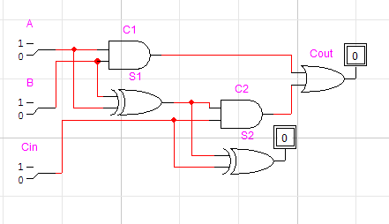

|  |  |  |  |  |
| --- | --- | --- | --- | --- |
| **A** | **B** | **Cin** | **Cout** | **S2** |
| 0 | 0 | 0 | 0 | 0 |
| 0 | 0 | 1 | 0 | 1 |
| 0 | 1 | 0 | 0 | 1 |
| 0 | 1 | 1 | 1 | 0 |
| 1 | 0 | 0 | 0 | 1 |
| 1 | 0 | 1 | 1 | 0 |
| 1 | 1 | 0 | 1 | 0 |
| 1 | 1 | 1 | 1 | 1 |